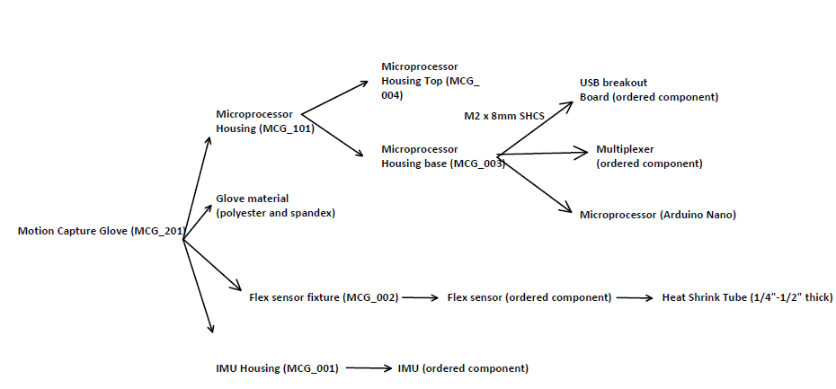
Figure xx: MoCap component diagram tree

All parts manufactured in-house should follow the same nomenclature as seen above. MCG_ indicating (MoCap glove), value in the tenths place indicates the file type: 200 – main assembly, 100 – sub-assembly, and 000 – single component. The hundredth and thousandth place are dedicated solely to which part you are working with. Drawings for the modeled component can be seen below.

Following the drawings are ECNs (Engineering Change Notification), created throughout the manufacturing process. The changes are direct products of trial and error upon printing the housing for the components. Each change is linked to a component and can be found in the upper right of the ECN document

